Coursework 1

Li-ion Battery Modelling

# Objective of the coursework

The aim of this coursework is to develop a behavioural model of a LiFePO4 cell and compare it to the real response of a cell.

# Requirements

The model will have the cell current as an input () and must return the cell voltage () and surface temperature () as an output as displayed in the following figure:

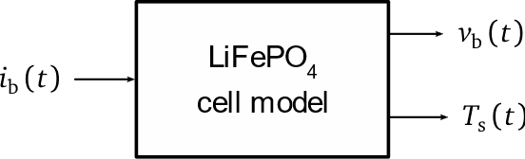

The following sections describe the main parts that this model must contain.

## Electrical part and OCV

The equivalent circuit of the cell, which is illustrated in Figure 1, should include the following parts:

* Cell open circuit voltage (OCV): this parameter depends on the state of charge (SoC)
* Equivalent impedance: the circuit must be comprised of a series resistance () and two  branches in series, and all the elements must be dependent on the SoC

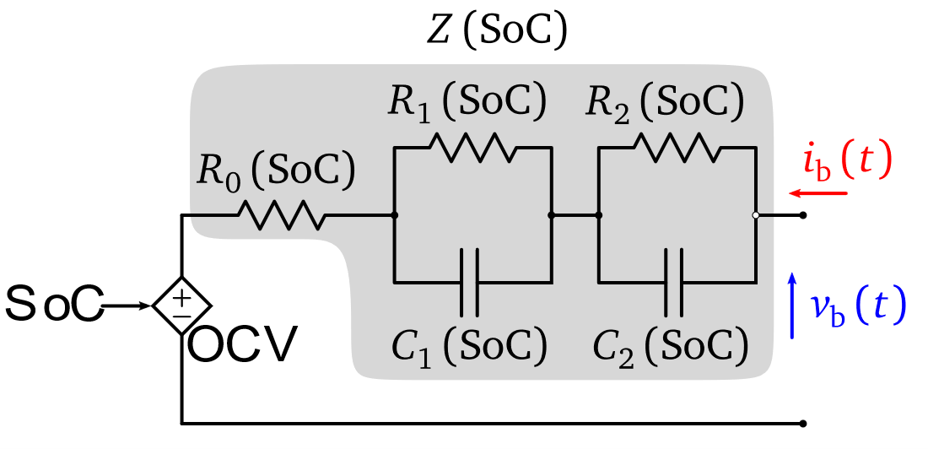

Figure 1 - Equivalent electrical circuit for a Li-ion cell

The data of the OCV and the impedances are provided in.mat files (‘OCVData.mat’ and ‘RCData.mat’) that must be loaded into Matlab/Simulink. **In order to interpolate this data in Simulink, the use of Lookup tables is recommended.**

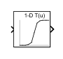

Figure 2 - Block of a Lookup table in Simulink

In this specific case, the **rated capacity of the cell is 7.6 Ah** and the **initial SoC is 80%** (approximately 6.05 Ah).

## Thermal part

The thermal part should consider on the one hand the heat generated in the cell and on the other hand its temperature distribution.

The generated heat should be calculated according to the following simplified equation:

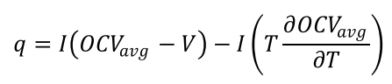

The temperature distribution should be estimated by integrating the following circuit in the simulation model:

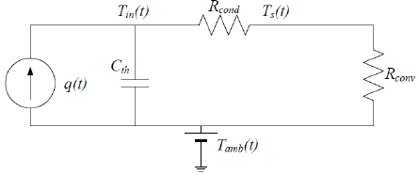

In this case, the thermal capacitance () has a value of 273 and the conduction thermal resistance of the cell () is equal to 1.5. The convection resistance of the air () is 3.6 and the ambient temperature () is equal to 25ºC.

# Model validation

In order to evaluate how good is our model, we have to compare the voltage given by the electrical model with the real voltage of the cell **for the same current profile**. This means that we must input the current profile employed in the real test in our simulation so that the cell model returns the voltage. The following figure illustrates how this validation should be carried out.

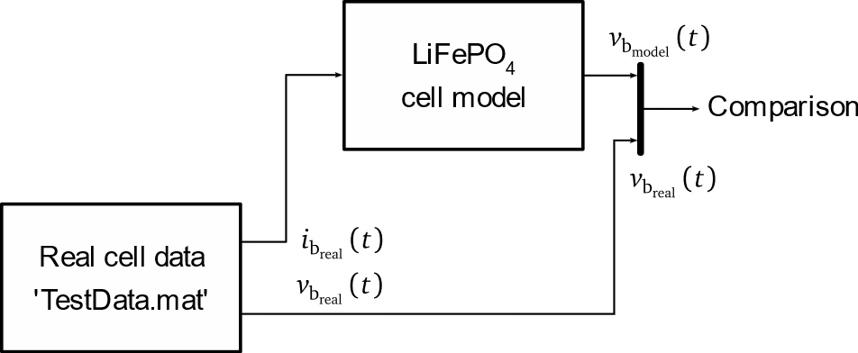

Estimate the absolute error of your model for the previous current profile according to the following equation:



From the calculated error, **determine the maximum error** in the validation test.

# Report

Apart from the simulation files, the students have to provide a report explaining the different parts of their model, and different graphs showing which is the evolution of the cell surface temperature as well as the comparison of the cell voltage with the real data. **The structure of the report, as well as the quality of the content and format will be thoroughly revised**.

# Submission

The students have to submit a compressed file (.zip, .rar, etc.) with all the simulation files and the report. The name of the file should contain the first letter of the name and the first surname of both group members and the coursework name, e.g.: ‘CW1_UIraola_IAizpuru.zip’