EXERCISE 4
A battery Pack for a house connected to a Solar Power Plant needs to be sized.
When the sun shines it feeds the electric loads for the house, but when it´s cloudy the Solar Panel will not give energy and in that case the loads need to be fed from an existing Battery Pack.
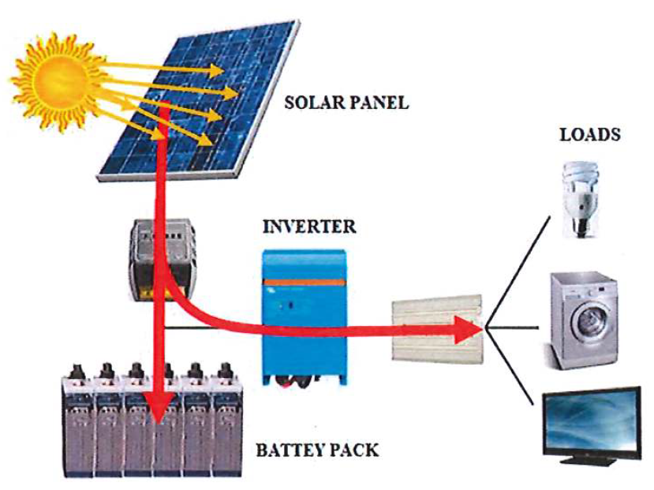
Figure 1: Sunny day
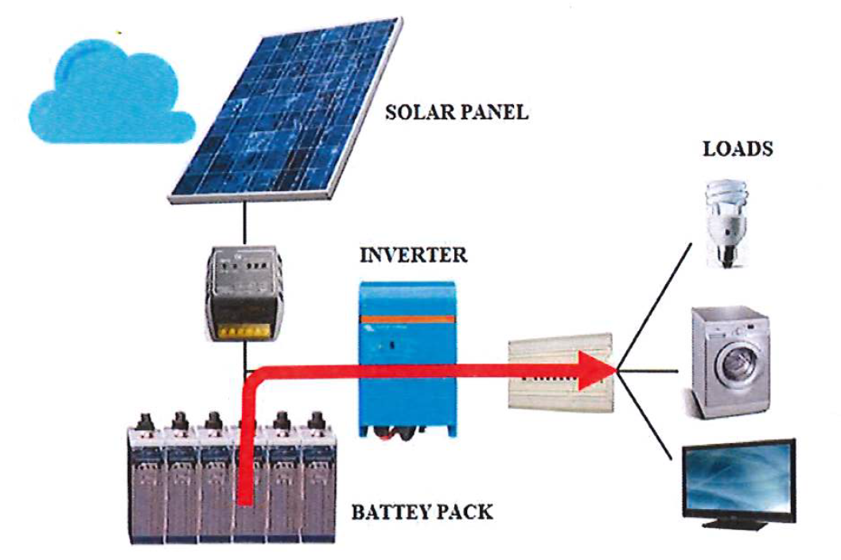
Figure 2: Cloudy day

The Battery Pack shall be sized to be able to feed the loads for a period not longer than 2 days.
The table below shows the load consumption during a day:
- Freezer: 1 unit x 120W x 7h -> 840Wh/day
- Microwave: 1 unit x 800W x 0,1h -> 80Wh/day
- Television: 1 unit x 85W x 5h -> 425Wh/day
- Lighting: 6 unit x 10W x 6h -> 360Wh/day
- Hydraulic pump: 1 unit x 750W x 1h -> 750Wh/day
- Washing machine: 1 unit x 550W x 1h -> 550Wh/day
The Battery Pack voltage shall be of 24Vdc.
QUESTION 1) How much is the energy discharged from the Battery Pack during those days?
QUESTION 2) Which shall be the nominal energy of the Battery Pack if during those two cloud days the allowed ΔDoD is limited to 50%?
QUESTION 3) Which is the average discharge current from the Battery Pack for a cloudy day? Give the answer in Amp and in C-rate.
QUESTION 4) In the worst case all the loads can coincide at the same time, which is the current drawn from the Battery Pack in that case? Give the answer in Amp and in C-rate.

