***EXERCISE 3:***

An Electric Vehicle has a Battery pack composed of 30 strings in parallel and 5 modules in series per String. The configuration of each module is 40S1P.

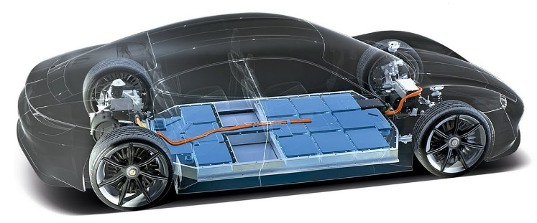

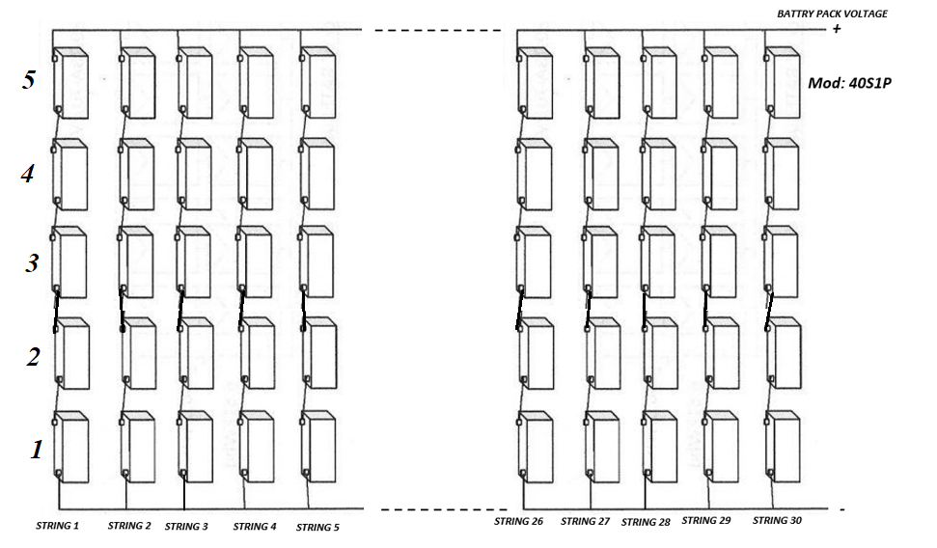

Each module is made using cylindrical NMC cells:

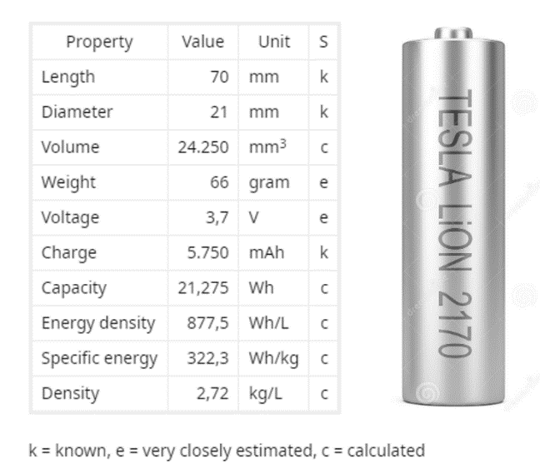

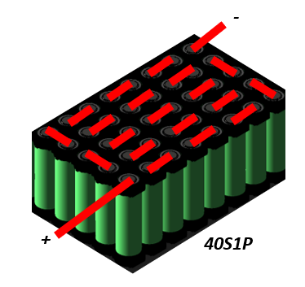

**Question 1) ¿Which is the nominal voltage and energy of each Module?**

Answer 1: 148V, 851Wh

**Question 2) ¿Which is the nominal voltage and energy of the Battery Pack?**

Answer 2: 740V

**Question 3) ¿How many cells are there in the Battery Pack?**

Answer 3: 6000

**Question 4) ¿Which is the Nominal Energy of the Battery Pack?**

Answer 4: 127kWh

**Question 5) The Electric Vehicle average consumption is 170Wh/km, which is the rangeof the Electric Vehicle for a DOD of 90%. Converters efficiency of 100%.** <https://ev-database.org/cheatsheet/energy-consumption-electric-car>

Answer 5: 672km

**Question 6) The Battey Pack is charged at 0,3C. ¿Which is the total power charging level in W?**

Answer 6:

0.3C: 1,725A per cell

1,725A per string

51,75A per Battery Pack

Average charging power: 740V x 51,75A: 38,3kW

**Question 7) ¿ How much does it last to charge completely the Battery Pack if charged at 2C?**

Answer 7:

2C: 11,5A per cell

11,5A per string

345A per Battery Pack

Average charging power: 740V x 345A: 255kW

Time to recharge ΔSOC of 100% (127kWh) at 255kW charging power: 0,5h (30 minutes)

**Question 8) Consider ESR per cell of 1mΩ. ¿Which are the losses on cells during 2C charging process?**

Answer 8:

2C: 11,5A per cell

Cell losses: 132,2mW

Battery Pack losses: 793W