EXERCISE 1
We want to have a house isolated from the main grid for a period of 6 days.

During these 6 days the house elecric loads (TV, Microwave, Whasing machine, oven, fridge,
lighting) shall be supplied from a Battery Pack. At the seventh day the Battery Pack will be
completely recharged again.
List of electric loads in the house:

- The TV consumes 50W and works for 4 hours a day
- The lighting consumes 10W and works for 6 hours a day
- The whasing machine consumes 1kW and and works for 2 hours a day
- The oven consumes 2kW and works during 1 hour a day
- The fridge consumes 300W and woks 4 hours a day

The Battery Pack shall be able to supply the house loads during the 6 days the house is isolated
from the grid.
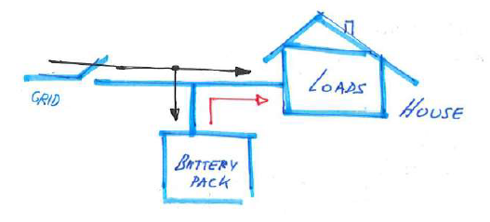
Figure 1: Schematic of the proposed problem.
Question 1: Determine the needed Battery Pack Nominal Energy (Wh) have a maximun Depth of Discharge DOD of 30% during those 6 days in which the house is isolated from the main electrical grid.

Question 2: Use the following lead acid battery to make the battery pack for the application. The power converter on the battery pack needs 48Vdc in the DC side.
