**BATTERY PROPOSED EXERCISES (1)**

**EXERCISE 1) We have a Battery with 60Ah/24V/ ESR:1mΩ**

Q1) ¿ How much electrical charge does the battery store when it is new (BOL: Beginning Of Life) and the SOC is 100%?

Q2) ¿ How much electrical charge does the battery store when it is new (BOL: Beginning Of Life) and the SOC is 72%?

Q3) ¿For what value of SOC is the nominal energy of the battery defined?

Q4) ¿How much is the Nominal Energy (Wh) of the Battery at BOL?

Q5) After two years of use a complete discharge is made (ΔDOD of 100%) at 6Amp. This discharge test last 7hours and 48 minutes.

¿How much electrical charge has been extracted during the test? Give the answer in Ah

¿ Which is the SOH of the battery after these two years?

Q6) Calculate the level of average losses due to the Joule effect at BOL if the effective value of the current that passes through the battery is 0.8C

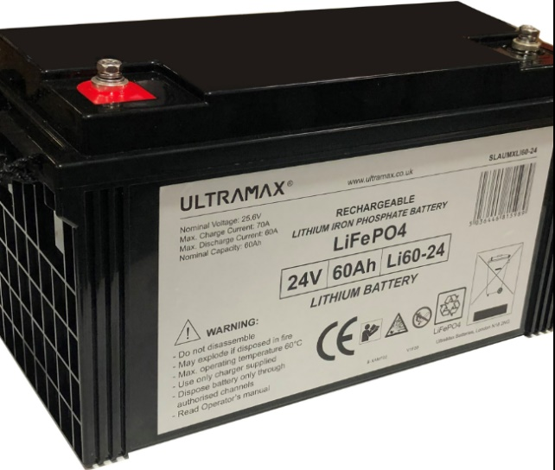

*ANSW1) 216000 Coulomb*

*ANSW2) 155520 Coulomb*

*ANSW3) SOC of 100%*

*ANSW4) 1440Wh*

*ANSW5) 46,8Ah, SOH of 78%*

*ANSW6) 0,8C: 48Arms Mean Joule losses: 2,3W*

**EXERCISE 2) Battery voltage profile**

Next image shows battery voltage profile.

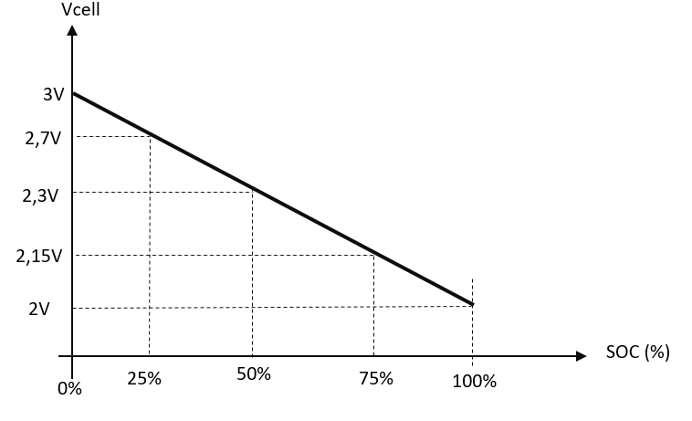

Battery nominal capacity of 25Ah

Battery weight: 400gr

Battery dimensions: 22mm x 100mm x 80mm

Q1) ¿How much is the Nominal Energy (Wh) of the Battery at BOL?

Q2) Determine the energy density of the cell

Q3) Determine the time in hours needed to discharge DOD=100% if the cell is new and the discharge current is 0.4C

Q4) Determine the time in seconds needed to discharge DOD=25% if the cell is new and the discharge current is 7.5Amp.

Q5) Determine the time in seconds required to perform a DOD=50% discharge if the cell has a SOH=85% and is discharged at 1C

ANSWER1) 57,5Wh

ANSWER2) 143,75Wh/kg 326,7Wh/L

ANSWER3) 2,5hours

ANSWER4) 3000seg

ANSWER5) 1530seg

**EXERCISE 3) Battery Pack configuration analysis**

Next image shows a Battery Pack configuration:

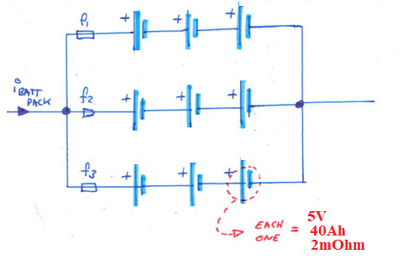

Q1) ¿How much is the Battery Pack nominal voltage?

Q2) ¿ How much is the Battery Pack nominal Capacity?

Q3) ¿ How much is the Battery Pack nominal Energy?

Q4) ¿How much are the Joule losses in the whole Battery Pack at BOL conditions if the total Battery Pack current is 120Arms?

Q5) Suppose that fuse 2 is blowed.

Battery Pack nominal voltage? nominal Capacity? nominal Energy?

ANSWER1) 15V

ANSWER2) 120Ah

ANSWER3) 1800Wh

ANSWER4) 28,8W

ANSWER5) 15V, 80Ah, 1200Wh

**EXERCISE 4) Battery Pack configuration analysis**

Next image shows a Battery Pack configuration:

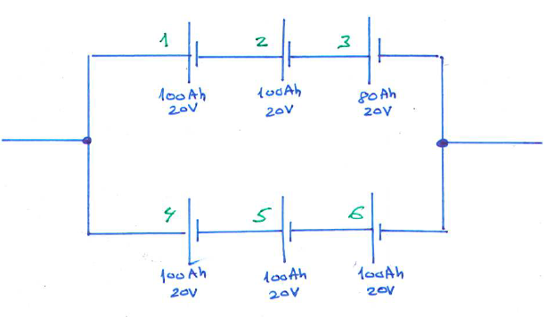

Q1) ¿How much is the Battery Pack nominal voltage?

Q2) ¿ How much is the Battery Pack nominal Capacity?

Q3) ¿ How much is the Battery Pack nominal Energy?

ANSWER1) 60V

ANSWER2) 160Ah

ANSWER3) 9600Wh