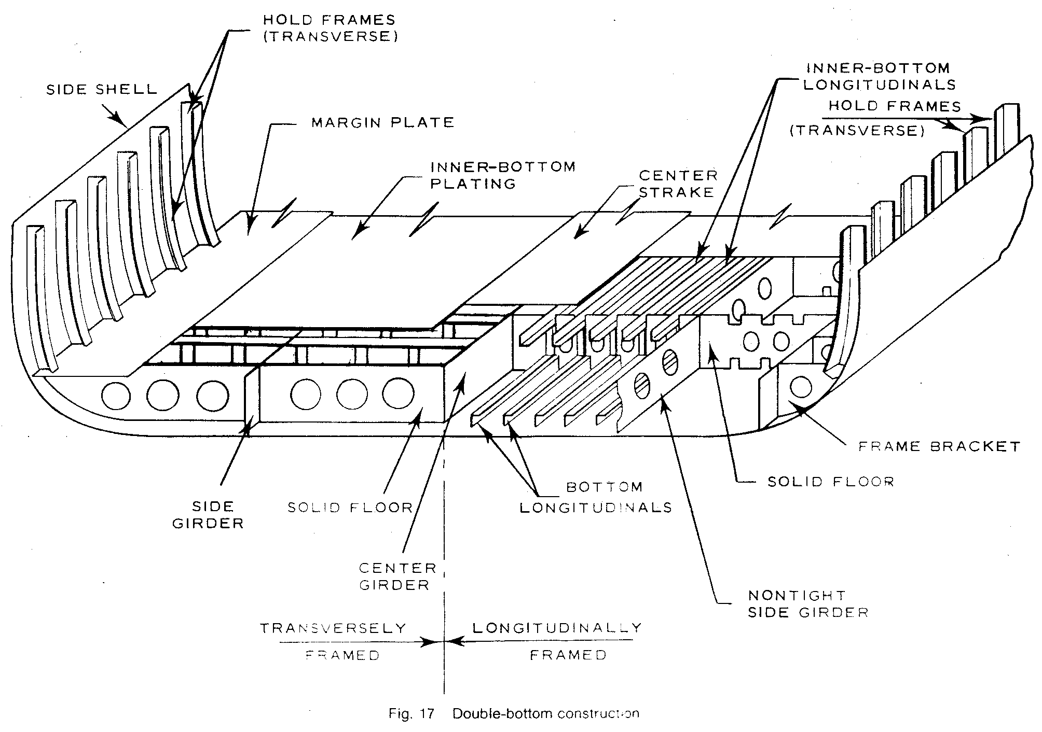

Fig. 17 Double-bottom construction
Fig. 17 Double-bottom construction

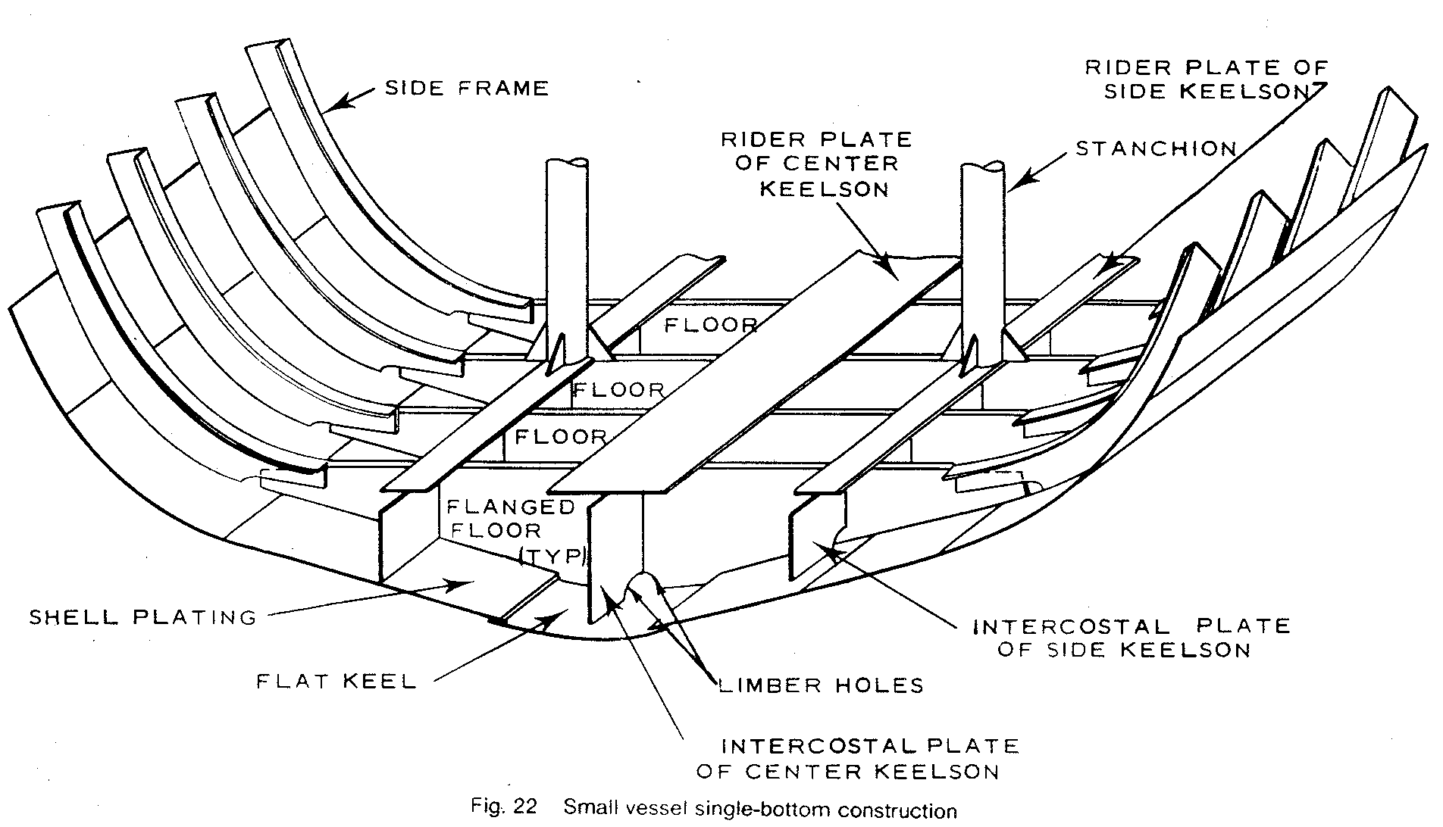
Fig. 22 Small vessel single-bottom construction

