TITLE OF THE PAPER

SECOND LINE OF THE TITLE

**First Author (John E. DOE)**

First Authors Affiliation

e-mail

City, Country

**Second Author**

First Authors Affiliation

e-mail

City, Country

**Others Author**

Other Authors Affiliation

e-mail

City, Country

## Resumen

Resumen ejecutivo en español. La primera página se reserva para el título del trabajo, los autores, la afiliación, palabras claves y el resumen en Español e Inglés (máximo 300 palabras).

## Abstract

Abstract in English. The first page is reserved for the title for the paper, the authors, affiliation, keywords and the abstract in Spanish and English (Max 300 words).

## Palabras Clave: clave1; clave2; clave3; clave4; clave5

## Keywords: keyword1; keyword2; keyword3, keyword4, keyword5

# Introduction

In order to ensure uniform style throughout the volume, all paper has been prepared strictly according to the instruction set below. The paper has to be sent both in WORD document using this template and in PDF format. The body of the paper should be written in Spanish or English. Authors should submit the paper electronically to: conferencia_puentes@acct.cl before May 31, 2021.

## General Specifications

Please use this file as a template for the paper. The paper including figures, tables and references together with the first page must not exceed length of 8 pages.

## Title, Authors, Affiliation, Keywords

The first page must contain the Title, Author(s), Affiliation(s), Keywords and the Abstract. The second page must begin with the Introduction.

The title should be written centered, in 14pt, boldface Calibri. The title does not exceed the 100 characters

The author’s name should be written as: First/given name; Initial of middle name; last/family name (in capital letters). It should be written in 10 pt. boldface Calibri.

The abstract should neither be too short nor exceed the first page and must be written in Spanish and English. The abstract text should be written in 9pt, Calibri.

## Header and Headings

The header should be written centered, in 8 pt. Calibri.

The main heading should be written left aligned, in 12 pt. boldfaced Calibri. The secondary heading should be written left aligned, in 10 pt. boldfaced Calibri

## Text

The normal text should be written justified, using 10 pt (Calibri).

## Equations

A displayed equation has to be numbered, using Arabic numbers in parentheses. Please refer to the example below. The following example is single line equation:

 (1)

## Figures

All figures should be positioned left aligned, numbered consecutively and captioned. The caption title should be written left aligned in 8pt Calibri, with upper and lower case letter. Please refer to the example below (Figure 1).

Figure 1. Golden Gate bridge (Example, 2014).

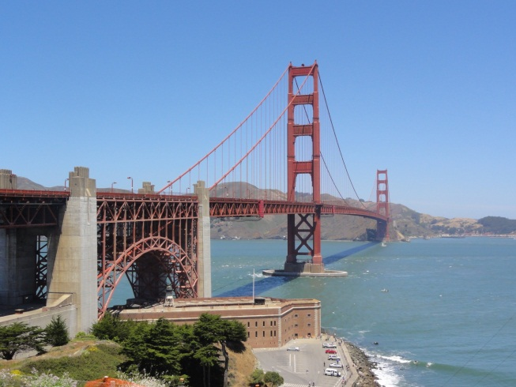

## Tables

All tables should be positioned centrally in the column, numbered consecutively and captioned. The caption should be 8pt Calibri. Please refer to the following example.

**Table 1.** Ranking span bridges (Example2, 2012)

|  |  |  |  |  |
| --- | --- | --- | --- | --- |
| Typology | Span range (m) | | | |
| 200 - 400 | 500 - 900 | 1000 - 1400 | 1500 - |
| Cable Stayed | yes | yes | no | no |
| Suspension | Yes | yes | yes | yes |

# Format of References

At the end of the paper, list all references underneath the heading References. Please refer to the example bellow (Doe, 2004).

# References

AASHTO (1993). American Association of State Highway and Transportation Officials. AASHTO Guide for Design of Pavement Structures 1993. American Association of State Highway and Transportation Officials: Washington, DC.